
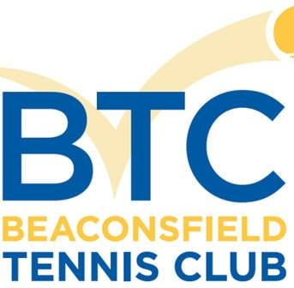
2025 CLUB CHAMPIONSHIPS
ENTRY FORM

DATE OF TOURNAMENT: OCTOBER 4TH AND 5TH

TOURNAMENT CATEGORY: JUNIOR/SENIOR SINGLES & DOUBLES

PHONE CONTACT: Paul Osborne 0413 594 633

ENTRIES CLOSE: SEPTEMBER 30, 2024 (with the Tournament Director: Paul Osborne)
Only email entries will be accepted: ossie30@bigpond.net.au

ENTRY FEE: $10 PER PLAYER PER EVENT (covers balls, trophies and BBQ lunch)
Payment on the day is required. All fees are to be paid prior to your first match.

EVENTS:
BOYS SINGLES (club championship)
GIRLS SINGLES (club championship)
GRADED JUNIOR UNISEX SINGLES
GRADED JUNIOR UNISEX DOUBLES (Sunday)
MENS SINGLES (club championship)
LADIES SINGLES (club championship)
SENIOR UNISEX DOUBLES (Sunday)
*Singles events will be played on Saturday (Oct 4). Doubles events will be played on Sunday (Oct 5).
*Advanced Junior members are encouraged to enter senior singles too.
*Trophies will be awarded to the winner(s) of each event.
Please complete your entry below and send to Paul Osborne by September 30th.
Email entries to: ossie30@bigpond.net.au
FULL NAME: |  | EVENT/S ENTERED:
PARTNER: |  | MOBILE:
EMAIL ADDRESS:
*First round match times will be confirmed via email on the Thursday evening prior to the tournament. *All players will compete in a minimum of 3 sets per event.

